**JUNIT Testing Exercises**

**Exercise 1:** Setting Up JUnit

**Scenario:** You need to set up JUnit in your Java project to start writing unit tests.

**Code:**

package com.example.junit_exercises;

import org.junit.Test;

import static org.junit.Assert.*;

public class MyFirstTest {

    @Test

    public void testAddition() {

        assertEquals(5, 3 + 2);

    }

}

**Output:**

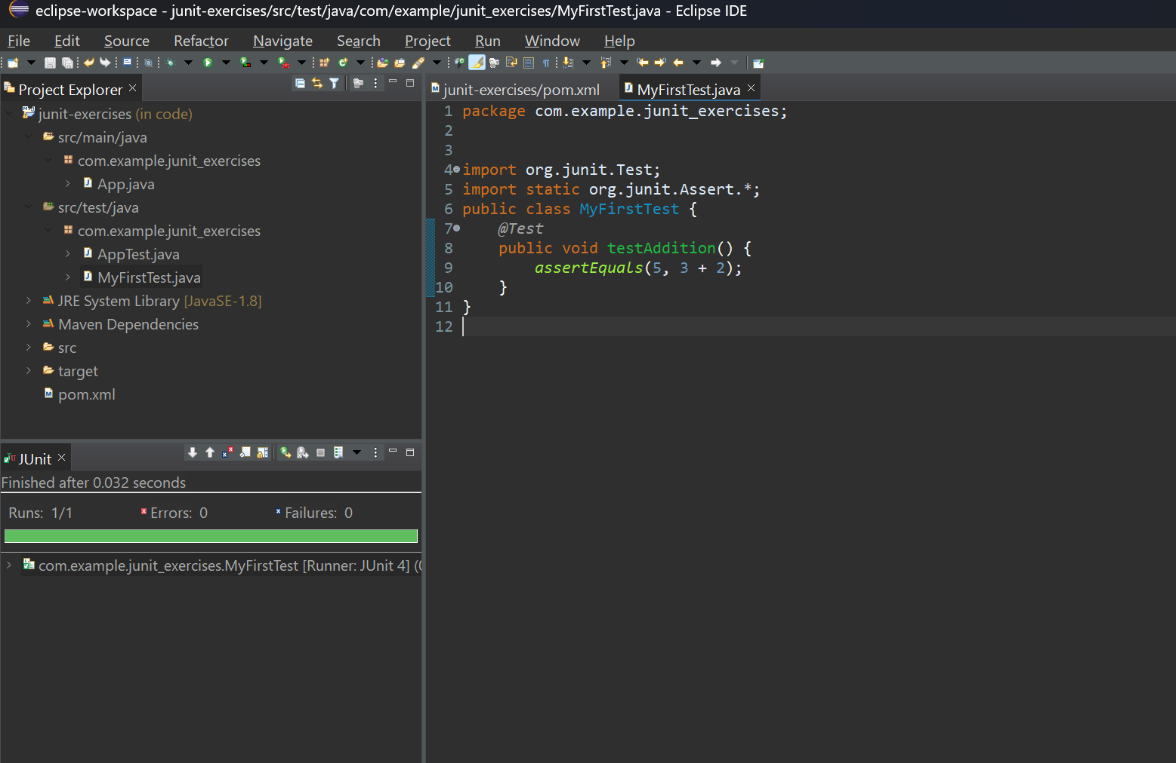

**Exercise 3:** Assertions in Junit.

**Scenario:** You need to use different assertions in JUnit to validate your test results.

**Code:**

package com.example.junit_exercises;

import org.junit.Test;

import static org.junit.Assert.*;

public class AssertionsTest {

    @Test

    public void testAssertions() {

        assertEquals(5, 2 + 3);

        assertTrue(5 > 3);

        assertFalse(5 < 3);

        assertNull(null);

        assertNotNull(new Object());

    }

}

**Output:**

**success case:**

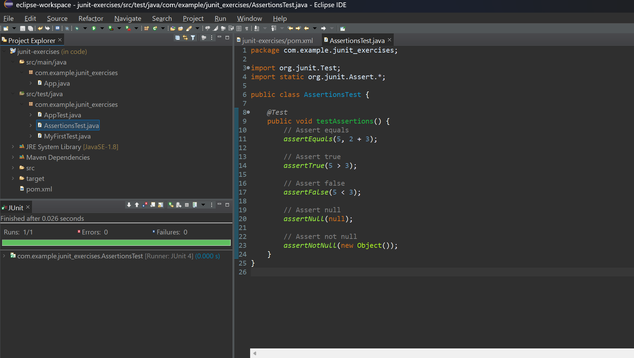

**Failure case:**

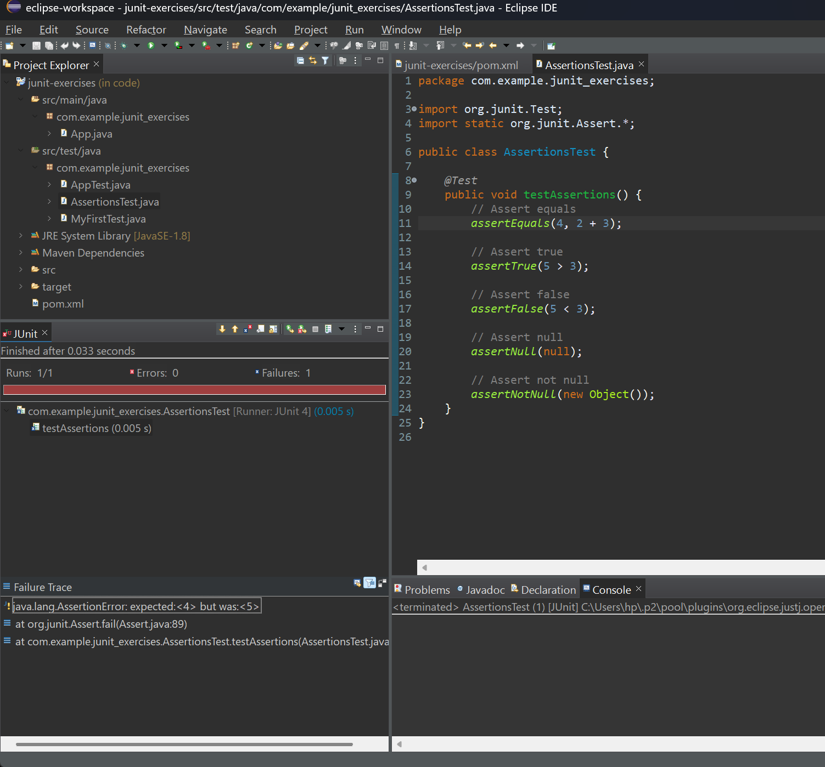

**Exercise 4:** Arrange-Act-Assert (AAA) Pattern, Test Fixtures, Setup and Teardown Methods in JUnit

**Scenario:** You need to organize your tests using the Arrange-Act-Assert (AAA) pattern and use setup and teardown methods.

**Code:**

package com.example.junit_exercises;

public class Calculator {

     public int add(int a, int b) {

            return a + b;

        }

        public int subtract(int a, int b) {

            return a - b;

        }

}

package com.example.junit_exercises;

import org.junit.Before;

import org.junit.After;

import org.junit.Test;

import static org.junit.Assert.*;

public class CalculatorTest {

    private Calculator calculator;

    @Before

    public void setUp() {

        calculator = new Calculator();

        System.out.println("Setup complete.");

    }

    @After

    public void tearDown() {

        calculator = null;

        System.out.println("Teardown complete.");

    }

    @Test

    public void testAddition() {

        int a = 2;

        int b = 3;

        int result = calculator.add(a, b);

        assertEquals(5, result);

    }

    @Test

    public void testSubtraction() {

        int a = 5;

        int b = 2;

        int result = calculator.subtract(a, b);

        assertEquals(5, result);

    }

}

**Output:**

**Success case:**

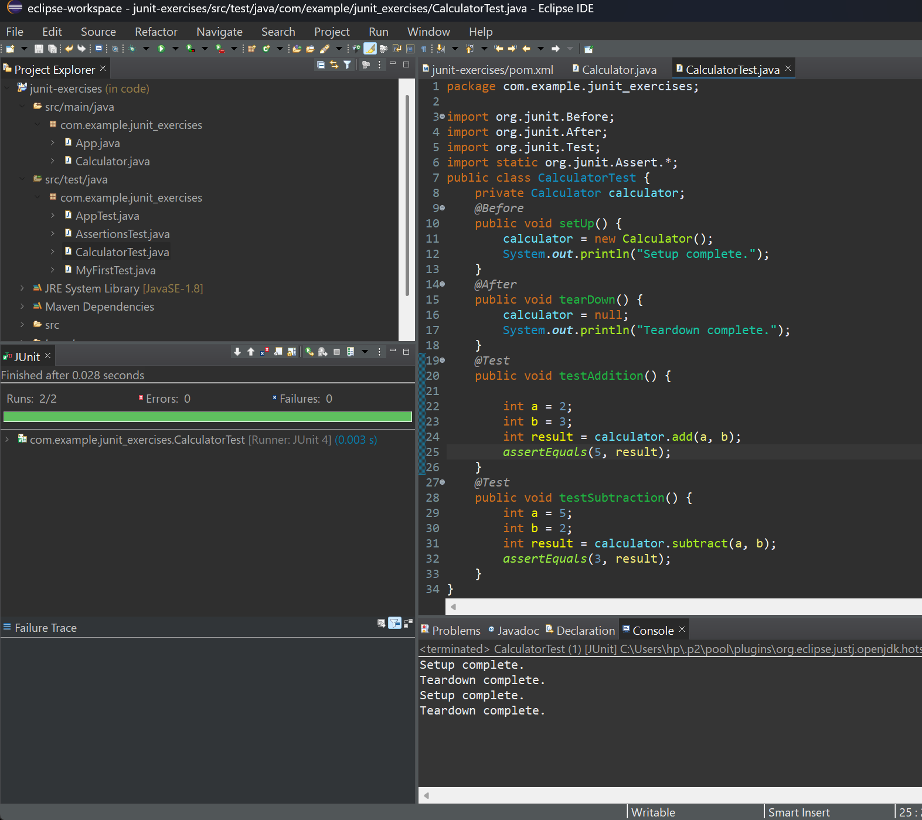

**Failure case:**

